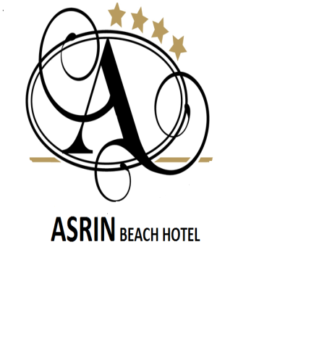
ALL INCLUSIVE PLUS CONSEPT ( 10:00-23:00) “SUMMER 2024”

Breakfast | 07:30 | - | 10:00 | Main Restaurant
Lunch | 12:30 | - | 14:00 | Main Restaurant
Snack Service | 11:00 | - | 17:00 | Beach Bar
Patisserie | 14:00 | - | 18:00 | Pool Bar
Corner Buffet | 12:00 | - | 18:00 | Pool Bar
Dinner | 19:00 | - | 21:00 | Main Restaurant
Night Soup | 23:00 | - | 24:00 | Main Restaurant

Lobby Bar | 10:00 | - | 02:00 | Lobby
Pool Bar | 10:00 | - | 23:00 | Pool
Beach Bar | 10:00 | - | 18:00 | Beach

FREE OF CHARGE
Beverage:
- Local Beer,Rakı, Wine, Vodka, Gin,Whiskey,Tequila,Rum,
- Local Malibu,Campari,Archers,Liqueur,Cocktail ,Martini
- Tonic water, Mineral water
- Concantrated Drinks (Peach, Orange, Cherry Juice. etc.)
- Tea, Herball Tea, Coffee, Cappucino
- Minibar (1 Water,1 Mineral Water) (C/in day)
Others
- Umbrella, Sunbeds, Mattress,
- Ice Cream (15:00 – 17:00)

EXTRA
- Import Drinks, Bottled Drinks
- Fresh Fruit Juice, Special Coffees,Turkish Coffe
- Quality Wine-Champagne
- Safe in the room
- Bath&Sauna,Massage, Peeling,
- Doctor
- All Water Sports on the beach ( Banana, parasiling, Jet-ski, and etc. )
- Beach Towels on the Pool and Beach
- Internet - Wi-fi
- Room towels are forbidden taking out
- Check out till 12:00

